main.cpp

// Ryan Jacoby

#include<cmath>

#include<iostream>

void hanoi(int);

void hanoi(int, char, char);

int main() {

int moves;

std::cout << "TOWERS of Hanoi\nEnter a number of disks to play. I'll give necessary moves.\n";

std::cin >> moves;

hanoi(moves);

std::cout << '\n';

return 0;

}

void hanoi(int n, char a, char b) {

if(n > 1) hanoi(n - 1, a, std::abs(5 - ((a - 64) \* (b - 64))) + 64);

std::cout << "Move a disk from post " << a << " to post " << b << '\n';

if(n > 1) hanoi(n - 1, std::abs(5 - ((a - 64) \* (b - 64))) + 64, b);

}

void hanoi(int n) {

if(n > 1) hanoi(n, 'A', 'C');

}

Run 1

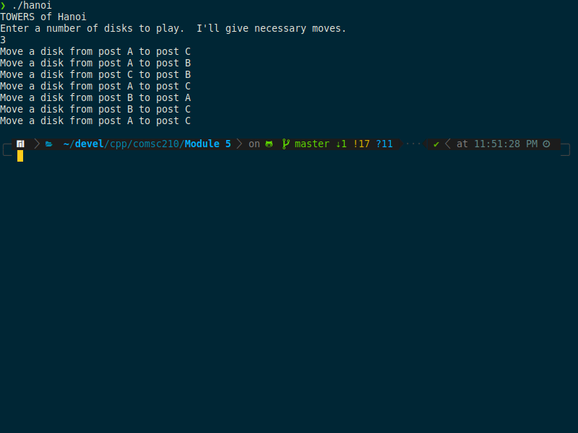

Run 2

